UNIVERSITY OF MANAGEMENT AND TECHNOLOGY
YEAR 3 GROUP J PROJECT DOCUMENTATION
CLOUD COMPUTING
Details
3. Savings Growth Calculator:
Input: Initial savings, monthly contribution, annual interest rate, time (in years).
Output: Total savings after the specified time.
Formulas used include: months = years * 12
To calculate the number of months
rate = (annual_rate / 100) / 12
This calculate the rate
total = (total + monthly) * (1 + rate)
This calculate the total savings amount
2. Loan Payment Calculator:
Input: Principal amount, annual interest rate, loan term (in years)
Output: Monthly payment.
Formulas used include: rate = annual rate / 100 / 12
This is to convert the annual rate to monthly rate
Then, months = years * 12
To convert years to months.
Payment = (principal * rate) / (1 - (1 + rate) ** -months)

Details of git and github usage:
After preparing our python calculations we used we the git bash to commit and push them into the repository.
Contributors: tahirujr, 076 574719 (morlford o kamara).
We invited Mr. Leigh but he did not confirm our invite.
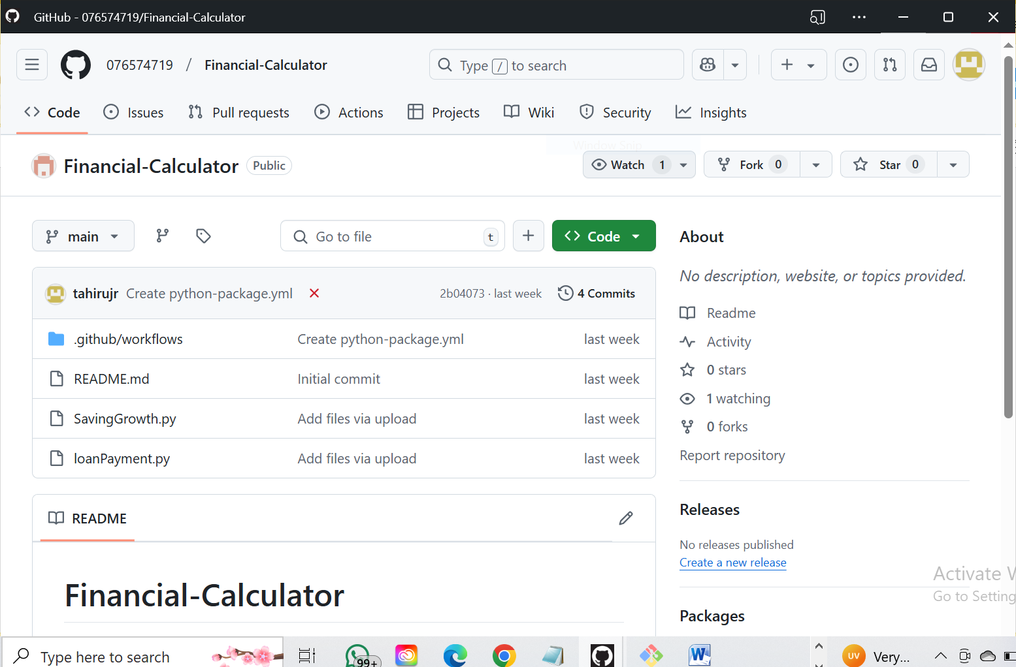

We faced challenges in areas such as:
Manipulating git and github everything was new.
Pushing files was our biggest challenge. In our team, we only have two people with computers.
However, we were able to collaborate with other peoples idea and was able to do the above.

